Our Mission: “We believe we have a duty to reduce our impact on our world, by continually creating solutions that ensure no resources are wasted. Without compromise.”
Our Vision: “Create a better world, by safeguarding our resources”

Our Values:
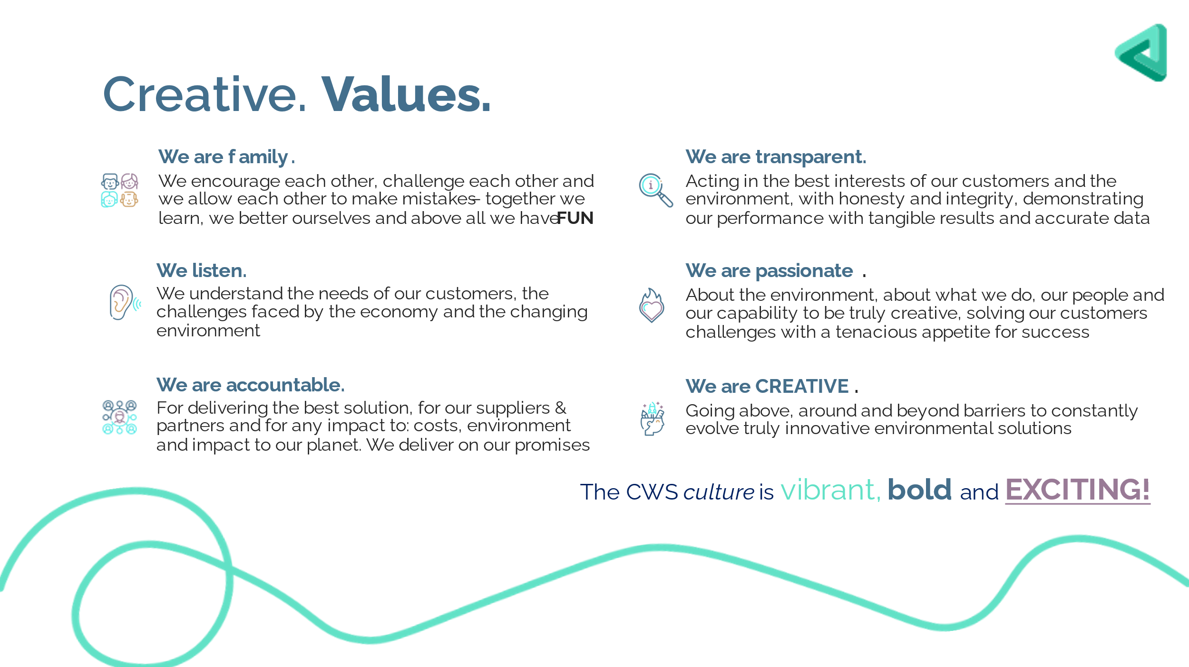
Job Title: | Business Development Manager (Northern)
Location: | Majority Field-Based
Reports to: | Sales Director
Coverage: | Northwest, Northeast, Yorks & Humber

Here at Creative Waste Solutions we are a family who all believe in and are motivated by our vision and mission. We want to continually grow. The foundations for our success are our happy employees who have fun coming to work.
We have created a culture and environment that acts as a catalyst for all our family to enjoy coming to work, develop personally and professionally and be successful.
This document aims to provide clarity on your role and your key responsibilities and what we will do for you to provide the clarity needed to succeed and activity contribute.
Your purpose
As part of our sales function, you are key to ensuring the continual growth of our business through providing solutions to our customers and being creative.
Working with the Sales director, you will be responsible for developing and converting a pipeline of legally compliant, profitable new business, that contributes to your own and the teams gross profit targets. Contracting business, delivering on agreed SLA’s and ultimately retaining business creates the foundations for our growth.
Developing trusting relationships with both waste producers/processors and our outsourced partners is key to foster the final vital part of your role. To be creative! We urge all our people to think creatively, challenge the norm and continually assess what great looks like now and in the future.
What we expect you to do
- Develop and manage the delivery of your sales pipeline to achieve your sales target. Pro-actively and re-actively selling profitable new business.
- Strategically prioritise your activities to focus your efforts on outcomes and profitable opportunities.
- Work with supply chain to ensure the best possible rates are secured and our buying power is exploited.
- As a member of our sales community, we expect you and the other members of the community to activity collaborate. E.g. sharing new best practice, experience/knowledge and supporting each other.
- Ensure new business is mobilised to prevent debt. Debt that occurs should be proactively managed and aged debt avoided.
- To engage in professional development through the delivery of your objectives and your own research into the waste industry.
- Supporting the sales director in the management of the tender process from PQQ through to ITT submissions.
- Coordinate the mobilisation of new business to ensure success and payment of invoices.
- Be the primary point of contact for your customers if they require a point of escalation or service development.
- Present supporting information and solutions to customers, in writing, verbally, through statistics and through formal presentations or business cases.
- Ensure all sales trackers, pipeline and site visit intelligence documents are regularly updated to ensure they remain valuable resources to the community.
- Time management should focus on known outcome of activities.
- You will provide weekly/monthly sales reports on your personal performance and effectiveness.

The skills you require:
Decision making – you will be able to independently make difficult and decisive decisions.
Active listening – “you have two ears and one mouth, use them in proportion” Richard Branson.
Deliver the structured sell & negotiation – Operating with integrity and confidence to consistently sell profitable solutions in accordance with a structured sales process.
Relationship building – Becoming a customers trusted advisor through delivering on what you said you would. You will have the ability to build strong relationships, with our network of suppliers and the departments that you will work with specifically, accounts, logistics and supply chain.
Numerical ability – you will be able to analyse data, calculate pricing ensuring that margin is in line or exceeds target expectations and have the ability to provide financial reporting when required.
Efficient organisation - you will need to work quickly and accurately with a strong eye for detail, so that your customers always get a good high-quality service
Efficient time management - to be able to manage your own workload through effective time management
Confident and capable IT skills – you will be using Microsoft Office, you need to have a good level of competence, being able to operate with confidence and without supervision. You must be able to present information quickly and clearly having the ability to use all the basic functions well
Great Customer Care - To be creative, focused and close to your customers driving excellence through customer care.
Quick thinking – you need to have the ability to think rapidly, clearly and decisively when under pressure.
Understanding the business – be able to learn, interpret and understand the business, the industry and the changing needs of our customers.
Inspirational leadership – Everyone can be a leader.
We will give you:
- A challenging and rewarding role in a successful and growing business.
- The opportunity to grow with a business through a tailored performance development programme.
- A competitive salary.
- A performance based related monthly bonus.
- Employer contributory pension scheme.
- A hybrid company car.
- A fuel card.
- A great place to work, where you feel you can make the most of your talents and purpose.

Version control | Job title | Author/sign off date
1.0 | Business Development Manager | Andrew Hind 07/11/2023

